ENCP 100 WS2020

Assignment 02

ZEESHAN HOODA

X61L — 01/23/20 at 2:00 P.M.

**ANSWERS FOR QUESTION 1:**

FLOW CHARTS

Problem 1 A: Problem 1 B: Problem 1 C:

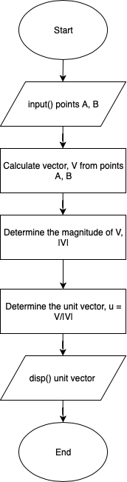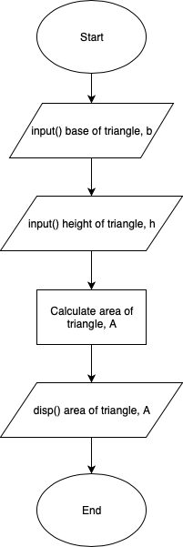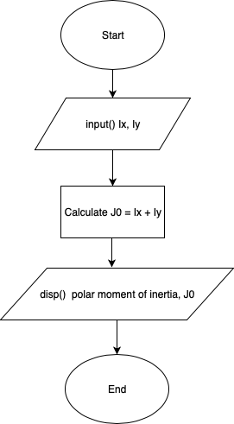

**ANSWERS FOR QUESTION 2:**

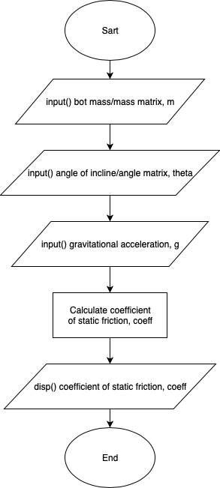

EXPRESSION FOR µ:

$$μ_{s}= \frac{mg\sin{θ}}{mg\cos{θ}}= \tan{θ}$$

|  |  |  |
| --- | --- | --- |
| m [kg] | Theta [º] | µ [] |
| 5 | 15 | 0.2679 |
| 10 | 20 | 0.3640 |
| 15 | 25 | 0.4663 |

**MATLAB CODE FOR QUESTION 2:**

clear all; clc; close all;

m = input('Input bot mass or mass matrix [kg]: ');

theta = input('Input angle of incline or angle matrix [deg]: ');

coeff = sind(theta)./cosd(theta);

disp(coeff);

**ANSWERS FOR QUESTION 3:**

EXPRESSION FOR CENTER OF MASS:

$$C_{x}=\frac{(\frac{L_{1}}{2}*m_{1}+ \frac{L_{2}}{2}*m_{2})}{(m_{1}+ m_{2})}$$

$$C_{y}=\frac{(\frac{H_{1}}{2}*m_{1}+ \frac{H_{2}}{2}*m_{2})}{(m_{1}+ m_{2})}$$

PSEUDOCODE:

🡪 Start program

🡪 Get m1, L1, H1, m2, L2, H2, dx, and dy from user

🡪 Calculate Cx and Cy

🡪 Display Cx and Cy on screen

🡪 End program

|  |  |  |  |  |  |  |  |  |  |
| --- | --- | --- | --- | --- | --- | --- | --- | --- | --- |
| m1 [g] | L1 [cm] | H1 [cm] | dy [cm] | dx [cm] | m2 [g] | L2 [cm] | H2 [cm] | Cx [cm] | Cy [cm] |
| 5 | 15 | 5 | 5 | 5 | 10 | 10 | 15 | 9.1667 | 9.1667 |
| 10 | 15 | 15 | 10 | 15 | 10 | 5 | 2 | 12.5000 | 9.2500 |
| 15 | 25 | 10 | 15 | 15 | 20 | 10 | 10 | 16.7857 | 13.5714 |

**MATLAB CODE FOR QUESTION 3:**

clear all; clc; close all;

m1 = input('Input m1: ');

L1 = input('Input L1: ');

H1 = input('Input H1: ');

dx = input('Input dx: ');

dy = input('Input dy: ');

m2 = input('Input m2: ');

L2 = input('Input L2: ');

H2 = input('Input H2: ');

x1 = L1./2;

y1 = H1./2;

x2 = dx + L2./2;

y2 = dy + H2./2;

Cx = (x1.*m1 + x2.*m2)./(m1+m2);

Cy = (y1.*m1 + y2.*m2)./(m1+m2);

disp(Cx);

disp(Cy);

**ANSWERS FOR QUESTION 4:**

EXPRESSION FOR RATIO, r:

$$r=\frac{[\left(W*H\right)-\left(\left(π*{r_{1}}^{2}\right)*n_{1}+ \left(π*{r_{2}}^{2}\right)*n_{2}\right)]}{(W*H)}$$

|  |  |  |  |  |  |  |
| --- | --- | --- | --- | --- | --- | --- |
| H [m] | W [m] | n1 [] | n2 [] | d1 [mm] | d2 [mm] | r [] |
| 0.5 | 0.5 | 23 | 30 | 10 | 30 | 0.9080 |
| 1 | 2.0 | 75 | 25 | 75 | 100 | 0.7362 |
| 0.75 | 1.0 | 120 | 76 | 30 | 50 | 0.6879 |

**MATLAB CODE FOR QUESTION 4:**

clear all; clc; close all;

H = input("Input H [m]: ");

W = input("Input W [m]: ");

n1 = input("Input n1 []: ");

n2 = input("Input n2 []: ");

d1 = input("Input d1 [mm]: ");

d2 = input("Input d2 [mm]: ");

circleArea = (pi.*r1.^2).*n1 + (pi.*r2.^2).*n2;

totalArea = H.*W;

freeArea = totalArea - circleArea;

ratio = freeArea./totalArea;

disp("r = ");

disp(ratio);